Histology of bone

The different types of cartilage vary in the amount and nature of fibres in the ground substance: hyaline cartilage contains few fibres, fibro-cartilage contains abundant collagen fibres, and elastic cartilage contains elastic fibres.

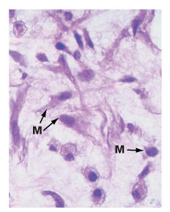
Cartilage formation commences with the differentiation of stellate-shaped, primitive mesenchymal cells to form rounded cartilage precursor cells called chondroblasts.

M – mesenchymal cells.

Subsequent mitotic divisions give rise to aggregations of closely packed chondroblasts which grow and begin synthesis of ground substance and fibrous extracellular material.

Secretion of extracellular material traps each chondroblast within the cartilaginous matrix thereby separating the chondroblasts from one another. Each chondroblast then undergoes one or two further mitotic divisions to form a small cluster of mature cells separated by a small amount of extracellular material. Mature cartilage cells, known as chondrocytes, maintain the integrity of the cartilage matrix.

Most mature cartilage masses acquire a surrounding layer called the perichondrium, composed of collagen fibres and spindle-shaped cells which resemble fibroblasts. These have the capacity to transform into chondroblasts and form new cartilage by appositional growth. There is also very limited capacity in mature cartilages masses for interstitial growth by further division of chondrocytes trapped within the previously formed matrix, and subsequent deposition of more matrix material. The hyaline cartilage of the articular surfaces of joints does not have perichondrium on the surface, and has no capacity to regenerate new cartilage after damage. In general, mature cartilage has a very limited capacity to repair and regenerate, partly because of its poor blood supply.

Most cartilage is devoid of blood vessels and consequently the exchange of metabolites between chondrocytes and surrounding tissues depends on diffusion through the water of solvation of the ground substance. This limits the thickness to which cartilage may develop while maintaining viability of the innermost cells; in sites where cartilage is particularly thick (e.g. costal cartilage), cartilage canals convey small vessels into the centre of the cartilage mass.

Bone

Bone is composed of cells and a predominantly collagenous extracellular matrix (type I collagen) called osteoid which becomes mineralised by the deposition of calcium hydroxyapatite, thus giving the bone considerable rigidity and strength. The cells of bone are:
- Osteoblasts - which synthesise osteoid and mediate its mineralisation; they are found lined up along bone surfaces.
- Osteocytes - which represent largely inactive osteoblasts trapped within formed bone; they may assist in nutrition of bone.
- Osteoclasts - phagocytic cells which are capable of eroding bone and which are important, along with osteoblasts, in the constant turnover and refashioning of bone.

Osteoblasts and osteocytes are derived from a primitive mesenchymal (stem) cell called the osteoprogenitor cell. Osteoclasts are multinucleate phagocytic cells derived from the macrophage-monocyte cell line.

Bone forms the strong and rigid endoskeleton to which skeletal muscles are attached to permit movement. It is also acts as a calcium reservoir and is important in calcium homeostasis. Bone is heavy and its architecture is optimally arranged to provide maximum strength for the least weight. Most bones have a dense rigid outer shell of compact bone, the cortex, and a central medullary or cancellous zone of thin interconnecting narrow bone trabeculae. The number, thickness and orientation of these bone trabeculae are dependent upon the stresses to which the particular bone is exposed; for example, there are many thick intersecting trabeculae in the constantly weight-bearing vertebrae, but very few in the centre of the ribs which are not subjected to constant stress. The spaces in the medullary bone between trabeculae is occupied by haemopoietic bone marrow.

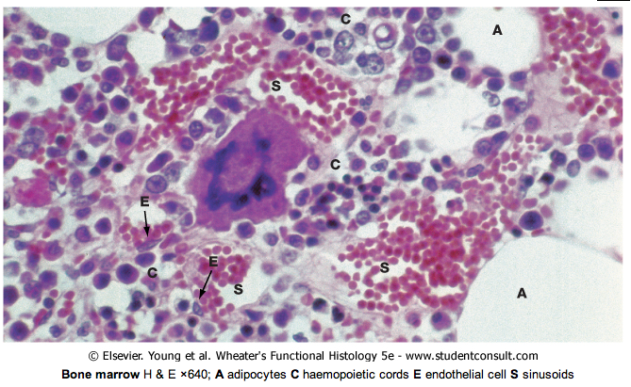

These micrographs illustrate osteoblasts actively depositing new osteoid on a bone surface. When active, the osteoblasts Ob are large broad spindle-shaped or cuboidal cells with abundant basophilic cytoplasm containing much rough endoplasmic reticulum and a large Golgi apparatus. These features reflect a high rate of protein (type I collagen) and proteoglycan synthesis. In (a), the tissue has been decalcified before sectioning and staining, so the distinction between mineralised bone and the newly formed unmineralised osteoid cannot be seen. In (b), which has not been decalcified, the mineralised bone (blue) can easily be distinguished from the new osteoid (red) which is being produced by the row of cuboidal osteoblasts; there is always a short delay between osteoid production and its mineralisation.

When inactive, osteoblasts are narrow attenuated spindle-shaped cells lying on the bone surface. In (a) the burst of new bone formation is nearly over, and the osteoblasts are becoming spindle-shaped again and will soon become virtually undetectable, only the long narrow nucleus being visible histologically. A few cells are being incorporated in the newly formed bone as osteocytes Oc.
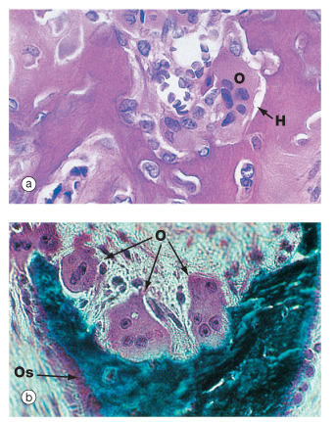

Resorption of bone is performed by large multinucleate cells called osteoclasts O which are often seen lying in depressions resorbed from the bone surface called Howship's lacunae H. The aspect of the osteoclast in apposition to bone is characterised by fine microvilli which form a ruffled border that is readily visible with the electron microscope. The ruffled border secretes several organic acids which dissolve the mineral component while lysosomal proteolytic enzymes are employed to destroy the organic osteoid matrix.

Osteoclastic resorption contributes to bone remodelling in response to growth or changing mechanical stresses upon the skeleton. Osteoclasts also participate in the long-term maintenance of blood calcium homeostasis by their response to parathyroid hormone and calcitonin. Parathyroid hormone stimulates osteoclastic resorption and the release of calcium ions from bone, whereas calcitonin inhibits osteoclastic activity.

Both (a) and (b) are taken from bone showing excessive osteoclastic activity due to disease (Paget's disease - see opposite). Micrograph (b) also shows uncoordinated new osteoid Os formation by a row of osteoblasts.

Bone exists in two main forms, woven bone W and lamellar bone L. Woven bone is an immature form with randomly arranged collagen fibres in the osteoid. Lamellar bone is composed of regular parallel bands of collagen arranged in sheets. Woven bone is produced when osteoblasts produce osteoid rapidly, as in fetal bone development and in adults when there is pathological rapid new bone formation, e.g. healing fracture and Paget's disease. The rapidly formed woven bone is eventually remodelled to form lamellar bone, which is physically stronger and more resilient. Virtually all bone in a healthy adult is lamellar.

