Blood Glucose Homeostasis and Diabetes Mellitus
Pancreatic β-cells
Pro-insulin is the initial substance formed from the pancreatic β-cells.
Pro-insulin is cleaved into insulin and a C-peptide.
C-peptide is the determining factor for the type of diabetes (T1 or T2)
Glucose Homeostasis
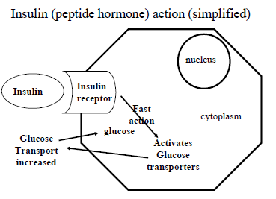
- Insulin binds onto insulin receptors on liver cells.
- By a rapid pathway, the insulin activates glucose transporters within the cytosol of the cell.
- Glucose transport from the blood into the cell increases leading the increased amount of glucose in the cell.
In those with T1DM, glucose in the blood increases in concentration and intracellularly, it decreases.
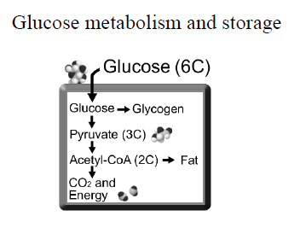
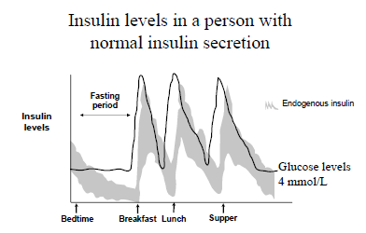
Hepatic glucose output
Hepatic glucose homeostasis depends on whether a person is in the post-absorptive (fasting) or post-prandial (following a meal) state.
Post-absorptive state
- The liver is the major source of endogenous glucose production (hepatic glucose output) through glycogenolysis and gluconeogenesis.
- Hepatic glucose output is reduced by insulin directly and indirectly through the suppression of glucagon secretion and through the reduction in circulating free-fatty acids (which stimulate gluconeogenesis).
- In insulin resistant subjects, hepatic glucose output is increased so they wake with fasting hyperglycaemia.
- Liver gets energy from fat oxidation
Post-prandial State
- The major source of glucose disposal is into muscle which is insulin mediated.
- Hepatic glucose output decreases because insulin levels RISE.
- Depending on the CHO content, glucose utilisation and oxidation increase in the muscles, liver and fat.
- The regulation of hepatic glucose uptake is complex and relates to glucose levels, insulin, free fatty acid concentration and other factors and hormones.
- In insulin resistant subjects, hyperglycaemia occurs following a meal mainly due to reduced insulin-mediated muscle uptake.

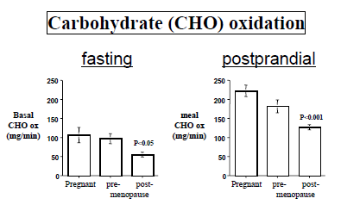
In a postprandial state, CHO burning will increase.
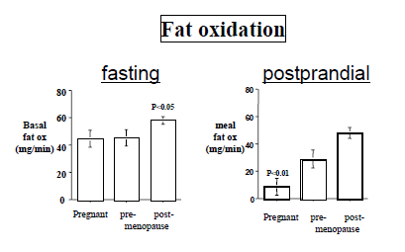
In a postprandial state, fatty acid oxidation will decrease. Rather, fatty acids, being easy to store and very energy efficient is stored in adipose tissue.

Diabetes Mellitus
 | Type I Diabetes | Type II Diabetes
Prevalence | <0.3% | Up to 8%
Age of onset | Usually <40 years old | Usually >30 years old
Cause | Insulin deficiency | Insulin Resistance
Identical Twins | 50% affected | 90% affected
Insulin therapy | Always | 25%
Obesity Related | No | Yes
Islet cell antibodies | Yes | No
C-peptide Levels | Low | Normal-High
Genetic Pre-disposition | Yes | More than T1

Diagnosis of DM
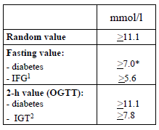
NB: OGTT = oral glucose tolerance test; IGT = impaired glucose tolerance
Pancreas
The pancreas has exocrine and endocrine functions.
The enzymes are produced to digest protein, CHO and fats.
Insulin is produced by the beta cells nested in the islets in the pancreas and glucagon is produced by the α-cells.

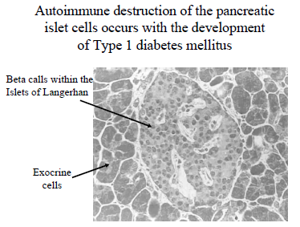
Initially there is an inflammatory response with β-cells producing decreasing amounts of insulin.
After a period of extensive damage to β-cells, insulin deficiency results.
Autoimmune Disease of T1DM
The immune system fails to recognise the beta cells and insulin as its own and begins to attack and destroy them.
Newly diagnosed persons with T1DM have:
- Islets cell antibodies (ICA)
- Autoantibodies to insulin (IAA)
- Antibodies to glutamic acid decarboxylase (GAD)
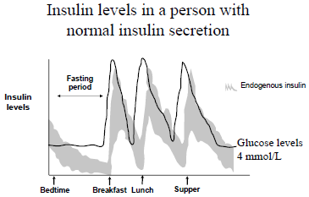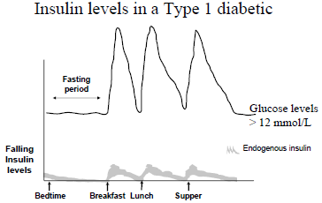
For normal insulin secretion, during bedtime, blood glucose concentrations are low and flat. Hyperglycaemia only occurs for any subsequent meals than occur during the day and blood glucose concentrations will decrease to basal levels.
For T1DM, the basal glucose levels are much higher and considered hyperglycaemic. Moreover blood insulin levels remain very low. Thus the hyperglycaemic episodes commonly seen in normal people after meals are intensified in T1DM sufferers.
Aetiology
An environmental trigger initiates selective autoimmune destruction of the pancreatic cells in genetically predisposed individuals. It is multifactorial.
Insulin secretion decreases as more cells are destroyed.
The patient eventually becomes totally insulin deficient and hyperglycaemia.
About 90% of beta-cells must be destroyed before obvious symptoms are noted.
Glucose Metabolism
- Insulin deficiency leads to reduced anabolic effects.
- Insulin deficiency depressed glucose transport and glycogen synthesis in skeletal muscle so less glucose is removed from the blood.
- Hepatic glucose production is not suppressed.
- This combination of events leads to hyperglycaemia.
- Produces symptoms of polyuria and polydispia. This is because glucose is an osmotic molecule so it carries water easily.
- Diabetic ketoacidosis may develop.
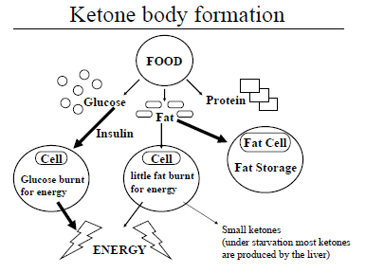
Normal person Ketone body formation

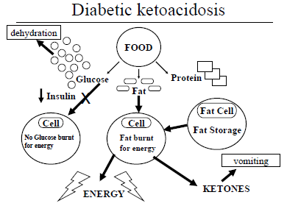
In T1DM, there is an immediate lack of glucose cellular uptake due to insulin deficiency caused by the destruction of pancreatic beta-cells. Energy thus is required to be derived from fats only and glucose is not actively transported into cells.
Serum glucose concentrations increase. This leads to dehydration due to osmolar effects of glucose in the urine.
Fat metabolism increases and dominates out of need and storage. Ketone bodies are thus produced rapidly and in large concentrations. This leads to unsafe and toxic build up of ketones thus the patient becomes acidoic leading eventually to ketoacidosis. This further intensifies the dehydration of the individual and vomiting secondary effects.

Diabetic Ketoacidosis: Consequences
High glucose levels
- Polyuria secondary to the osmotic diurectic effects of glucose.
- Polydyspia (increased drinking)
- Dehydration related to increased urine output and vomiting.
Ketone Bodies
- Sweet smelling breath.
- Nausea, vomiting and abdominal pain.

Diabetic Ketoacidosis: Causes
- First presentation of T1DM
- Infections – gastroenteritis and pneumonia
- Surgical procedures when nil by mouth.
- Missing regular insulin (non-compliance)
Principles of Insulin Replacement
- Aim is to mimic the physiological secretion of insulin
- Normal pattern of insulin secretion has a basal level with a peak after each meal.
- Basal-bolus strategy aims to mimic this using short and long acting insulin.
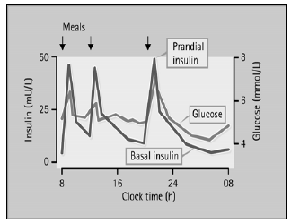

Type II Diabetes
T2DM is associated with increasing weight, age and reduced exercise.
Insulin resistance
- Moderate reduction in the biological response to insulin
- Rarely it is due to insulin antibodies or insulin receptor defects
- Insulin resistance is a clinical condition and not a specific pathological entitiy
Insulin resistance reflects a state of reduced biological action to insulin. In other words, for a standard amount of insulin, less glucose is taken up in the cells (mainly muscle cells). Insulin sensitivity is how sensitive a person is to insulin. So as insulin sensitivity declines, insulin resistance increases. Therefore, insulin sensitivity and insulin resistance can be seen as opposite descriptions of biological insulin action.

Obese subjects, patients with Type 2 diabetes and patients on corticosteroids are all insulin resistant. When the patients on corticosteroids cease these medications their insulin resistance can resolve (their insulin sensitivity improves).

One way to determine insulin resistance is to infuse IV a standard amount of insulin (eg 4 units per hour) into a fasting subject. Therefore, to maintain a steady glucose level of 5 mmol/L in a normal person, approximately 150 mmols of glucose will need to be infused per hour. However, to maintain a steady glucose level of 5 mmol/L in an insulin‐resistant person (receiving 4 units per hour IV), only 75 mmols of glucose may need to be infused per hour. In this case, insulin action is reduced and they are regarded as insulin resistant. These nfusion are generally used a research methods.
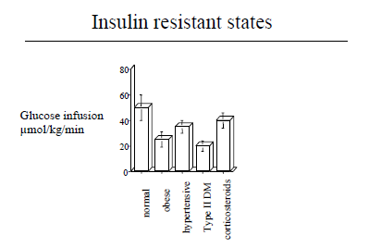
Clinical Characteristics of Insulin resistance Syndrome/ Metabolic Syndrome
- Impaired glucose toleratnce – Type II DM
- Obesity
- Dyslipidaemia – low HDL, high LDL, high TG
- Hypertension
- Raised Uric Acid Levels
- Raised plasminogen activator inhibitor-1
- Sleep Apnoea
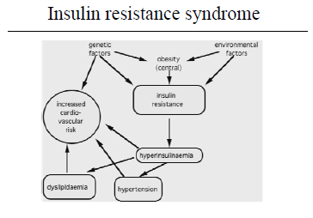
Genetic Characteristics – it is suspected that a collection of genes are responsible for the manifestation of T2DM.
Environmental factors include a western lifestyle: high glucose and fat food content, easy access to food and sedentary lifestyle.
T2DM sufferers have much larger stores of visceral fat which is metabolically active which is detrimental to our health.
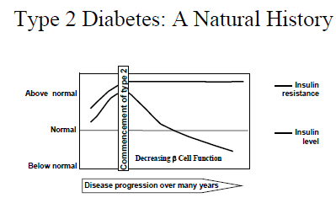
In T2 diabetics, insulin level function is initially normal but decreases gradually over time. Later their insulin levels decrease until insulin requirements are required.
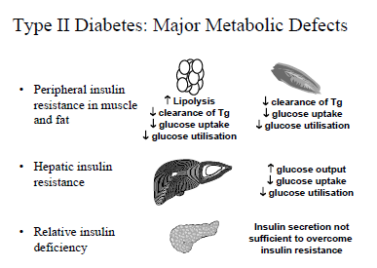
Managment of Diabetes
Dietary changes
Exercise
Education and Monitoring of Glucose Levels
Oral Medication (T2DM only)
Insulin therapy (T1 all and 25% T2)
Prevention (only T2DM)
Lifestyle Interventions (Diet and Exercise)
- Reduces the incidence of T2DM by 58% over 4 years
- Reduced body weight by 4-6kg
To prevent one case of diabetes, 7 subjects must participate in a lifestyle intervention program.

