SH Phase 2 Virtual Microscopy Practical Class - Skin Neoplasms
Aim: The aim of this practical class is to introduce you to some common skin neoplasms.
Learning objectives:
- Recognise the macroscopic appearances of common skin neoplasms.
- Describe the microscopic appearances of common skin neoplasms and correlate this with clinical manifestations.
- Discuss factors predisposing to the development of skin tumours.
- Explain how histological features of skin tumours can assist in determining prognosis.
The presentation should include a histopathological description and microscopic diagnosis of the lesion, followed by a discussion of clinical features, risk factors and predisposing conditions, prognostic indicators and any other relevant information.

Adaptive Tutorial

Question 1
This is a low power view of a section through a squamous cell carcinoma of the skin.
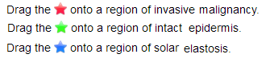
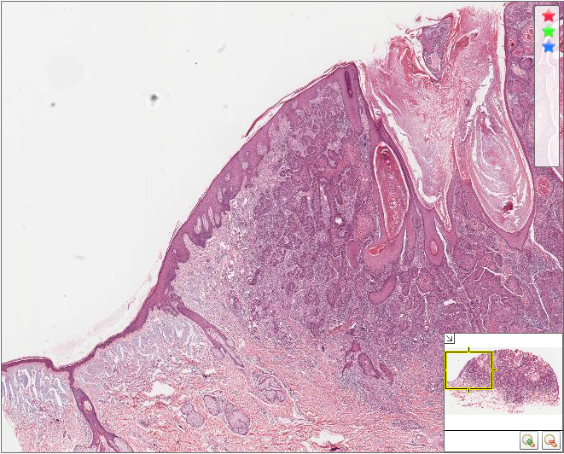
The region of carcinoma is highlighted in red. This consists of invading nests of cohesive polygonal cells (hence this is a malignant neoplasm exhibiting epithelial differentiation). Some of the nests show differentiation to produce eosinophilic whorls of keratin. Between the nests of cells is reactive stroma, consisting of blood vessels, connective tissue and inflammatory cells.
The epidermis is highlighted in green. Some areas of the epidermis exhibit dysplastic changes, which are a precursor to invasive malignancy.
The region of solar elastosis is highlighted in blue. Chronic UV injury to fibroblasts in this region has resulted in abnormal elastic fibre synthesis and fragmentation of dermal collagen, leading to abnormal basophilic staining.
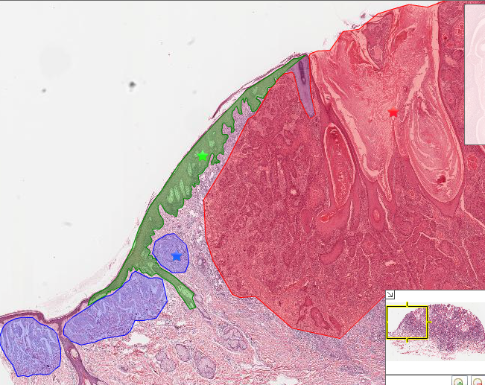

Question Two
With reference to the above slide, all of the following abnormalities of the skin are associated with chronic UV-induced injury, EXCEPT:
- Solar elastosis
- Solar keratosis
- Seborrhoeic keratosis
- Squamous cell carcinoma
- Basal cell carcinoma
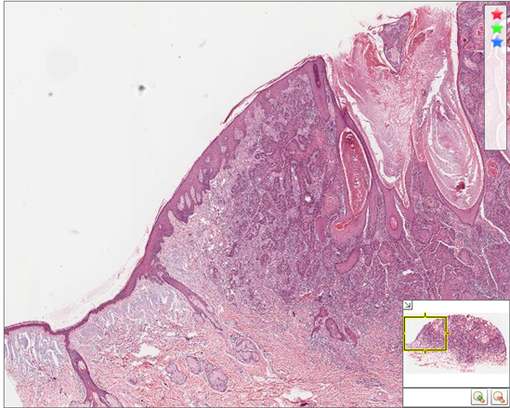
- Answer: Seborrhoeic keratosis
  - There is little evidence linking UV exposure to the risk of developing seborrhoeic keratoses, which are benign lesions that occur most often on the torso of middle-aged and older individuals.
- Solar elastosis: Chronic UV injury to fibroblasts results in abnormal elastic fibre synthesis, resulting in the accumulation of deposits of basophilic staining material in the dermis. This is accompanied by fragmentation of dermal collagen.
- Solar keratosis: Chronic UV injury results in dysplasia of basal cells of the epidemis, as well as hyperkeratosis. Solar (actinic) keratoses are very common pre-malignant lesions, and are markers of increased risk of malignancy in surrounding skin.
- Squamous cell carcinoma: The risk of squamous cell carcinoma of the skin is proportional to cumulative lifetime UV exposure.
- Basal cell carcinoma: The risk of basal cell carcinoma of the skin is proportional to cumulative lifetime UV exposure, and has also been linked to brief intense UV exposure.

Question Three
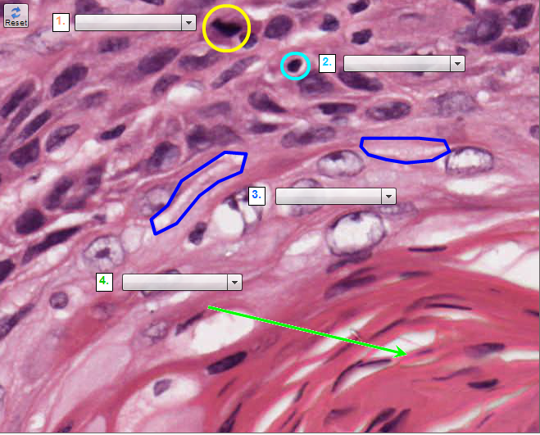
- Mitotic Figure: This is recognisable as a mitosis by the presence of a mitotic spindle of chromosomes, with loss of the nuclear membrane. This should be distinguished from an apoptotic body, in which the contents of the nucleus are condensed.
- Apoptic Body: This is recognisable as an apoptotic body, in which the contents of the nucleus are condensed. This should be distinguished from a mitotic figure, in which there is a mitotic spindle of chromosomes, with loss of the nuclear membrane. The contents of the nucleus are condensed in this cell.
- Desmasomes: There are intercellular bridges between adjacent cells, indicating that these cells are connected via desmosomes, typical of the stratrum spinosum of the epidermis. In contrast, gap junctions are close connections between two cells (e.g. neuronal synapses) which permit ions to move freely between cells.
- Keratin Pearl: The neoplastic cells in the centre of this nest have undergone differentiation to produce a whorl (or pearl) of keratin (eosiniphilic protein). This is an indicator of good differentiation in this type of malignancy.

 