Renal Blood Flow, Filtration and Clearance
The kidneys are the primary means of eliminating waste products of metabolism. These products include urea (from the metabolism of amino acids), creatinine (from muscle creatine), uric acid (from nucleic acids), end products of haemoglobin breakdown (such as bilirubin) and metabolites of various hormones.
Urine Formation
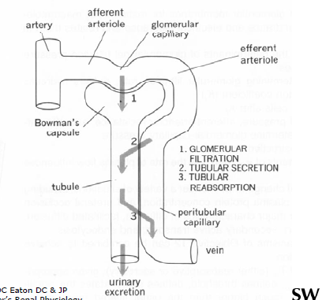
There are 3 key stages towards urine formation:
- Glomerular filtration – plasma flows along the glomerular membrane into Bowman’s capsule.
- Tubular secretion – material from the peritubular capillary enters the tubule
- Tubular reabsorption – material from the tubule enters the peritubular capillary

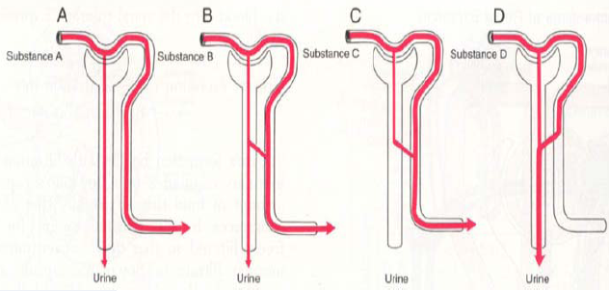
The above diagram denotes 4 types of filtration:
- Material from afferent arteriole is freely filtered with none being secreted or reabsorbed (e.g. inulin)
- Material from the afferent arteriole is freely filtered with some reabsorption but no secretion (e.g. Vitamin C)
- Material from the afferent arteriole is freely filtered but is TOTALLY reabsorbed (e.g. glucose).
- Material from the afferent arteriole is freely filtered and secreted completely from the arteriole (e.g. para-amino hippuric acid)
Blood supply to the Kidney
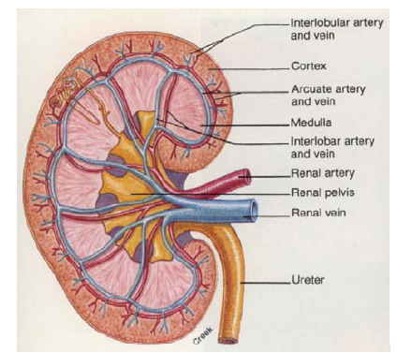
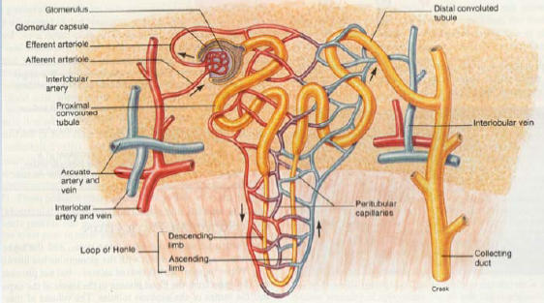
Blood supply to the kidneys follows the following pattern:
- Renal artery
- Segmental artery
- Interlobar artery
- Bowman’s capsule
- Arcuated arteries
- Interlobular arteries
- Afferent arterioles
- Glomerular capillaries
- Efferent arterioles
- Peritubular capillaries
- Venous drainage
Renal Blood Flow
- The rate is approximately 1200mL/min in Males, and 890mL/min in females.
- Renal blood flow is 20-25% of the resting cardiac output
- Blood flow is high [4mL/min/g] compared to other organs
- It is vital to expose the blood to filtration.
- A-V oxygen difference is low (63umol/100mL)
- Distribution of blood flow is as follows: 90% to cortex, 10% to medulla, and 1-2% to papillae.
- Renal plasma flow (RPF) = renal blood flow (RBF) (100-Hct)/100
Pressure in Renal Vessels
Pressure drops with blood flow travelling from the renal artery to eventually draining into the renal vein.
The glomerular capillary ressure is 45% of renal artery pressure which is very high for capillaries.
There are 2 large pressure drops which occur when blood flows in the afferent arterioles and efferent arterioles. This means these 2 sites are sites of resistance and by changing the restriction (dilation and constriction) of both the afferent and efferent arterioles, blood flow to the kidneys thus changes.

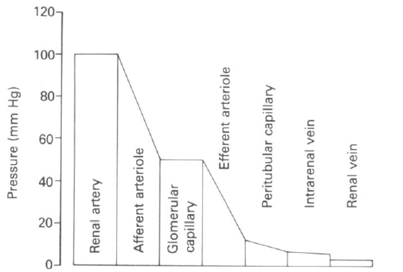
Changes in afferent or efferent arteriolar tone cause changes in the renal blood flow.
For any organ Q = P/R, where:
- Q = flow
- P = difference in hydrostatic pressure between the artery and vein
- R = vascular resistance
Thus if perfusion pressure is constant, this leads to the constriction of afferent or efferent arteriole which results in the RBF leading to increased resistance. Also the dilation of afferent or efferent arterioles results in the rise in RBF, leading to decreased resistance.
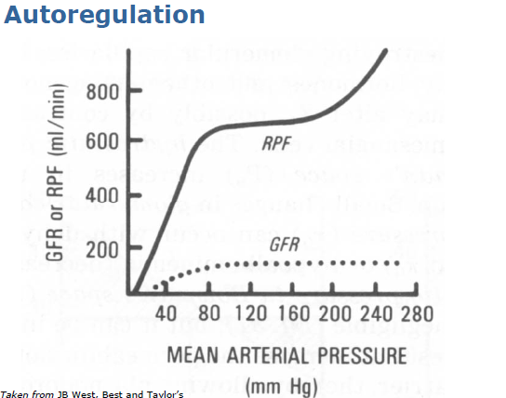
Despite changes in arterial pressure, the kidneys maintain relative constancy of renal plasma flow. The plateau of renal blood flow shown above is the auto-regulatory range which ranges from 75-180mmHg. The auto-regulatory function is an intrinsic property of the kidneys which does not rely on hormones or nerves. The property is caused by the myogenic reflex response of smooth muscle in the arterioles when they stretch or constrict.
- When blood pressure drops, the blood vessels will dilate to maintain the renal blood flow.
- When blood pressure increases, the blood vessels will constrict to maintain renal blood flow.
Other influences of RBF
Influences may over-ride autoregulation. These include:
- Angiotensin II (the activated peptide of the renin angiotensin system)
- Catecholamines
- Antidiuretic hormone (ADH)
Renin Angiotensin System
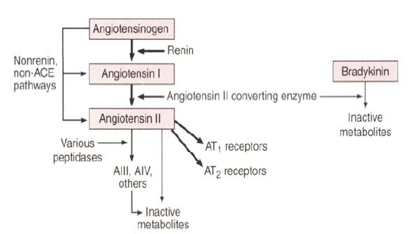
- Renin produced from the juxtaglomerular (JG) cells act on angiotensinogen to form angiotensin I (inactive form)
- Angiotensin I is activated by Angiotensin II converting enzyme (ACE) to form angiotensin II (activated form).
- [NB – ACE also participates in the breakdown of bradykinin.

Juxtaglomerular Apparatus
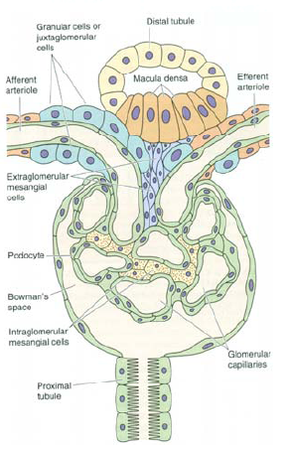
The JGA controls renin release. JGA consists of:
- Afferent tubule cells
- Efferent tubule cells
- Macula densa cells
- Extraglomerular mesangial cells.
Control of Renin release
- Renal baroreceptor. A drop in perfusion pressure leads to increase in renin production.
- Macular densa. These cells sense tubular transport. They detect Na and Cl and if these ions are low in concentration, renin output increases.
- Renal sympathetic nerves. Beta-stimulation increases the renin release.
- Feedback – the increase in the intravascular volume, blood pressure and improved renal perfusion inhibits release. Also the short feedback loop when AngII acts on J-G cells to inhibit release
- Increase – chronic hypokalaemia, PGE2
- Decrease – acute hypernatraemia, ADH, ANF

Actions of Angiotensin II
- Vascular-arteriolar vasoconstriction (via AT1 receptors)
- Renal – vasoconstriction, proximal sodium reabsorption, contraction of mesangial cells (affecting the GFR).
- Adrenal – aldosterone release (Na retaining hormone). Na retention leads to expansion of blood volume.
- Neural: facilitates sympathetic activity, inhibits vagus (inhibition of the vagus results in an increase in blood pressure. It is a very effective in inhibiting actions of the heart or other organs that control blood pressure.), increases ADH secretion, increases ACTH secretion, dipsogen (hormone that drives thirst).
Renal sympathetic nerves
- Rich supply of sympathetic noradrenergic neurones
- The cause is the vasoconstriction via alpha-adrenoreceptors, renin release via beta-adrenoreceptors on JG cells and increase in the Na and water reabsorption by the tubules.
- Small amounts of tonic discharge at rest in animals and humans

Glomerular Filtration
As blood flows through the glomerulus, an ultrafiltrate of plasma is formed. The ultrafiltrate has nearly the same composition of small molecular weight substances such as plasma.
Its rate of formations in called the glomerular filtration rate. Normal GFR is 125mL/min for males. (125mL/min = 7.5L/hr = 180L/day)
Filtration Barrier
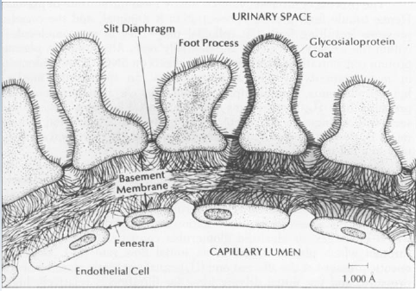
Endothelial cells are fenestrated with 60-80nm pores in diameter.
Glycocalyx coating occurs on the endothelium which is negatively charged and thus repels negatively charged proteins thus preventing protein leakage.
Foot processes contain diaphragms.
Forces governing filtration
- Qualitatively these forces are the same as those acting in systemic capillaries.
- SNGFR (single nephron GFR) = Kf * [net filtration pressure]
- Kf * [net filtration pressure] = Kf [(PGC - PT) - (πGC - πT)]
Where P = hydrostatic pressure
π = colloid osmotic pressure
GC= glomerular capillary
T = tubule
- Kf = glomerular ultrafiltration coefficient = effective surface area (A) * capillary wall conductivity (k)
Typical Pressures
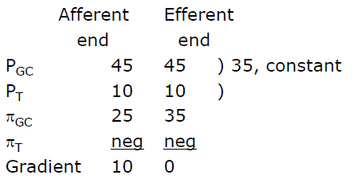
Factors changing GFR
- Renal blood flow – an increase in renal blood flow results in an increase in GFR as it takes longer for colloid osmotic pressure to rise.
- Changes in glomerular capillary hydrostatic pressure:
BP – increase in BP leads to increase in glomeruli pressure increase and thus the osmotic pressure rises.
Afferent tone – constriction of afferent arterioles causes a decrease in pressure downstream leading to a decrease in GFR. The opposite occurs for dilation.
Efferent tone – constriction of efferent arterioles causes a increase in pressure downstream leading to an increase in GFR. The opposite occurs for dilation.

Filtration fraction
Not all the plasma that flows through the glomerular capillary can be filtered into the Bowman’s space. This is to avoid clogging the glomeruli with proteins and plasma.
Filtration fraction = GFR/ RPF = 0.16-0.2
Measurement of GFR
To determine GFR we use a substance that is freely filtered at the glomerulus but then neither reabsorbed or secreted along the remainder of the tubule.
Criteria involved are:
- Not protein bound
- Not metabolised
- Not stored in the kidneys
- Not toxic
- Has no effect on the filtration rate
- Is relatively easy to measure in plasma and urine
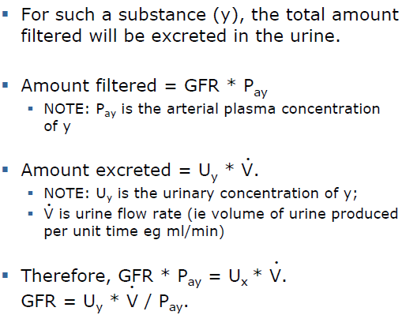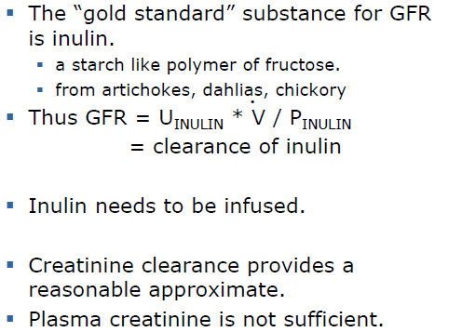
Measurement of RPF
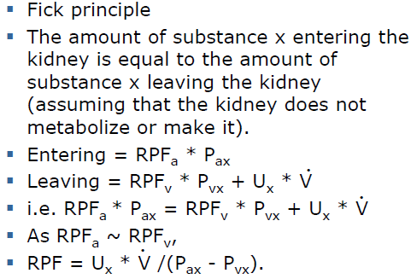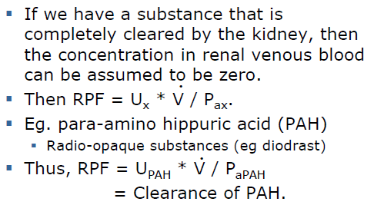

Effective Renal Plasma Flow
- Actually some PAH appears in the renal vein.
- Blood from the capsule, pelvis, perirenal fat and medulla
- Strictly, clearancePAH gives ERPF.
- ERPF = 90% of true RPF
- For most purposes, ERPF is adequate.

Renal Clearance
It is the measure of the success of how much plasma was cleared per unit time.
The renal clearance of a substance is the minimal volume of plasma which could have supplied the amount of substance which is excreted in the urine per unit time.
UNITs are volume of plasma/ unit time (mL/min)
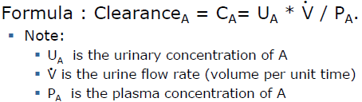
Clearance can tell doctors how the kidneys handles the substance one we know the clearance for other substances.
If Cx < GfR the x must be reabsorbed (if freely filtered)
If a substance is completely absorbed, the clearance will be zero. In a non-diabetic, no glucose is excreted. Glucose is freely filtered so it must be all reabsorbed.
A zero clearance value could mean the substance is not filtered.
If Cx > GFR, the substance must undergo net secretion.
The upper limit of clearance is C_{PAH}.

