Pharmacology
Contents
Pain and the Action of NSAID’s 2
Pharmacokinetics 3
CNS Pharmacy –Rats 4
Concentration Response Curves – Actions of Agonists and Antagonists 7
Pharmacology of the Human Autonomic Nervous System 8
Gene Therapy 9
Effect of Beta-Adrenoceptor Agonists on Exercise Induced Cardiovascular Changes 11
Drug Metabolism……………………………………………………………………………………………………………………………………………………14

Pain and the Action of NSAID’s
NSAIDs are among the most commonly used of all drugs, mostly used for mild to moderate pain management. The primary mechanism for action of NSAIDs is the inhibition of cyclooxygenase (COX) isoenzymes, which are involved in the synthesis of prostaglandins. COX-1, has the normal “housekeeping” functions of promoting the production of thromboxane (involved in platelet aggregation and clotting), protecting the GIT by producing mucus, nociception and involvement in pain pathways and a precursor for prostaglandins. COX-2 is induced by chemical inflammatory mediators, and it is involved in inflammation, fever, some pain, parturition, renal function and also a precursor for prostaglandins. Most traditional NSAIDs inhibit both COX-1 and COX-2, although new selective COX-2 inhibitors are in the market.
NSAIDs have three main effects: anti-inflammatory, analgesic (especially pain related with inflammation) and antipyretic effect (lowering of body temperature when it is raised by action of the COX-2 enzyme).

Side effects of NSAIDs include gastric irritation or ulceration, affecting renal blood flow and prolonging bleeding via inhibition of thromboxane (which also decreases risk of cardiovascular disease because the same anti-coagulant mechanism).

Scenario A
Patient is a 25 year old woman, who has fallen off her horse. She has pain on her left collar bone and suspects it might be broken. X-rays are taken which show a fracture in the left clavicle. The patient is given Pethidine to relieve the pain.
1. Are opiods appropriate in the management of pain resulting from fractures?
Yes, because they relieve acute pain as well as chronic. They are cheap and have a good risk to benefit ratio.
2. What are the contraindications and potential side effects of opiod use in pain relief?
Absolute contraindications: opioid allergy, drug interactions that are life-limiting
Relative contraindications: respiratory impairment (e.g. asthma, COPD), acute psychiatric instability or suicide risk, intolerance of opioids, inability for therapy compliance, sleep apnoea, elderly.
Side effects: dependence, tolerance, respiratory depression, constipation [decreased GIT motility] and CNS disturbances (e.g. hallucinations, dizziness), nausea, vomiting, miosis [pupillary constriction]/
3. What alternative analgesics or medications are available to treat fracture pain?
NSAIDs (such as aspirin), paracetamol.
Scenario B
Patient is a 38 year old male, with right knee osteoporosis, and has taken Celebrex (200mg/day), for the past 3 months. Initial condition did not respond well to paracetamol (oral). He then presents complaining of excessive pain in the right knee. Patient ceased taking the prescribed Celebrex (selective COX-2 inhibitor) for about 1 week, complaining that he had experienced excessive somnolence (drowsiness) and mild depression when taking the medication.
1. What are the contraindications and side effects of Celebrex?
Contraindications include NSAID-associated asthma, other concurrent NSAIDs and pregnancy.
Side effects include cardiovascular disease or thrombotic episodes, GIT irritation, headaches, abdominal pain, insomnia, nausea, flatulence and dyspepsia [indigestion].
2. Would you reinstate Celebrex? Why or why not?
Yes, because the patient’s complaint is not caused by Celebrex as he has been on it for 3 months [more likely due to effects on lifestyle and kiss if function] but the patient’s preferences and alternative medication should be explored.
3. What alternative medications are available for patients with this condition?
Non-selective NSAIDs, oral glucosamine sulphate, chondroitin sulphate, topical capsaicin, methyl salicylate.
Scenario C
34 year old female patient presenting with recurring headache, that have been occurring a few times a week for over a month. No specific triggers could be identified by the patient, but she states that her job has been very stressful lately. The patient has been taking aspirin 600mg/4hrs for the duration of the headache. She is also experiencing some gastric discomfort associated with the headaches. She has also noticed that she has been bruising more easily over the last month and is concerned about this.
1. What is the cause of her increased bruising (describe mechanism)?
The increased bruising is a side-effect of aspirin. Non-selective NSAIDs (such as aspirin) inhibit COX-1, which stops thromboxane formation and platelet aggregation. Therefore, clotting is much more difficult and causes sustained bruising as a result as minor capillary damage is not clotted.
2. Is the gastric discomfort associated with her condition or treatment, how would you determine this?
As stress and headaches are her complaint, GIT irritation is an unlikely association with these symptoms. Instead, it can be explained by the action of aspirin, which due to its inhibition of COX-1 and prostaglandin production, which are involved in gastric protection by mucus secretion. This can be confirmed through stopping treatment to see if effects subside.
3. What alternative treatment would you recommend for this condition that would not have undesirable effects of aspirin?
Counseling, relaxation techniques, stress management or paracetamol.

Pharmacokinetics
Graph
- Use semi-logarithmic paper:
  - Time on X-axis (linear (0, 1, 2, etc)
  - Concentration on Y-axis (logarithmic – eg 0, (0.01, 0.02,…0.09), 0.10, (0.20, 0.30…0.90), 1.00, 10.00, etc)
  - Draw straight line of best fit through end points (terminal linear phase)
- Look at route of administration:
  - For oral dosage – the first concentration and time point is 0,0 (ie begins at the origin)
  - For IV dosage – the concentration at time zero needs to be estimated, by extrapolating the distributional phase data back to the y-axis and reading off the concentration
Calculations
- Half-life (t½) = time taken for the plasma concentration to fall by half.
  - Can be read directly off log-linear phase of the graph (eg read off the x-axis the time between plasma conc being 1 and 0.5)
  - Dependent on clearance and volume of distribution
  - Eliminiation is about 94% complete after 4 half-lives.

- Elimination rate constant (k) = gradient of the log-linear phase of the graph. If half-life is known, k=0.693/t½ - Calculate area under the plasma concentration-time curve (AUC)
  - Either manually using the trapezoidal rule, or by entering data into computer
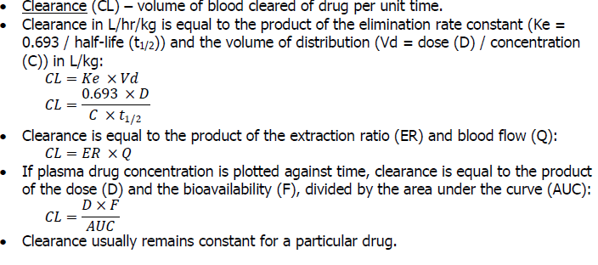

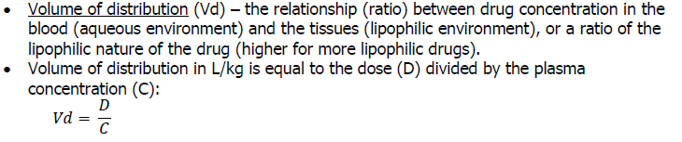

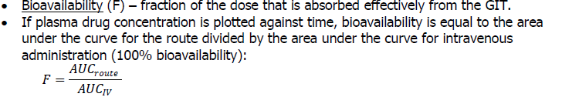

CNS Pharmacy –Rats
Behavioural screening tests are needed to see the effect of new compounds in terms of toxicities and effects. This is done on mice and rats and monitored for effects on awareness, mood, motor activity, CNS excitation, muscle tone and reflexes. This experiment uses pre-recorded video to demonstrate drug screening in live animals.

Part 1: Observation of behaviour responses to pharmacological agents.
Three classes of drugs – Hypnotics/Sedatives [Barbiturates/Benzodiazepines], Opioids [Morphine] and Stimulants [Amphetamine/Cocaine/Picrotoxin]
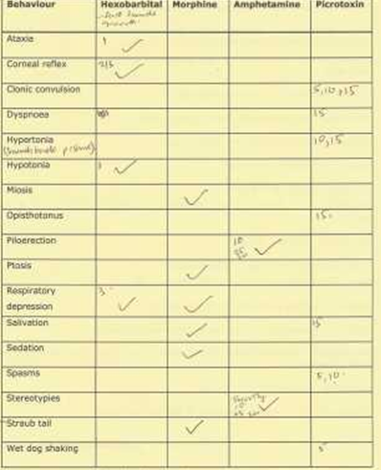
Definitions of behaviours:
Ataxia - loss of the ability to coordinate muscular movement.
Clonic convulsion - uncontrollable contractions of muscles marked by alternating contraction and relaxation of the muscles.
Corneal reflex - reaction of the eye to changes in light (change in the size of the pupil)
Dyspnoea - difficult or laboured breathing.
Hypertonia - excessive tone of the skeletal muscle.
Hypotonia -diminished tone of skeletal muscle.
Miosis - contraction of the pupil.
Mydriasis - dilation of the pupil.
Opisthotonus - a form of spasm consisting of extreme hypertension of the body.
Piloerection - erection of hair.
Ptosis - drooping or closure of the eyelids.
Salivation - secretion of clear alkaline from mouth.
Sedation - defined as the act or process of calm.
Spasms - sudden violent involuntary contraction of muscle.
Stereotypies – persistent repetition of stereotyped behavior, eg, preening and sniffing the floor.
Straub tail - raising the tail in the air.
Wet-dog shakes - twisting & shaking of the head and neck.

Part 2: Elevated Plus Maze
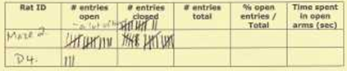

Questions:
Q1. The barbiturates are known to produce exciting ataxia and hypotonia prior to anaesthesia. What is the other predominant behavioural characteristic observed?
a. Opisthotonus
b. Clonic convulsions
c. Salivation
d. Mydriasis
e. Respiratory depression

Q2. A subject is given an unknown drug which produces anaesthesia. Upon awakening, the patient suffers amnesia for 3 hours. The drug is likely to be a type of:
a. Barbiturate
b. Opioid
c. Benzodiazepine
d. Cholinergic
e. Ether
Q3. Which of the following are the effects of benzodiazepines?
a. Reduction of anxiety and aggression
b. Anticonvulsant effect
c. Acts allosterically to increase of GABA for the GABAA receptor binding
d. Rapid eye movement (REM) sleep suppression
e. All of the above

b) Opioids
Q4. The distinguished behavioural characteristics of morphine as demonstrated in the video sequence above include
a. Sporadic activity
b. Straub tail
c. Hunched posture
d. Walking on tiptoe
e. All of the above

Q5. In addition to the decreased pain perception and sedative effects, morphine also has effects on the eye and typically produces:
a. Miosis
b. Ptosis
c. Mydriasis
d. Ptosis and Mydriasis
e. Ptosis and Miosis

Q6. Morphine produces its effects through activation of specific opioid receptors in the brain. The receptor responsible for producing most of the analgesic effects is:
a. δ receptor
b. μ receptor
c. κ receptor
d. σ receptor
e. α receptor

Q7. The most prominent clinically useful effect of opioids is reducing pain. Which of the following are unwanted effects of morphine?
a. Euphoria and respiratory depression
b. Sedation and dependence
c. Constipation
d. Both a and b
e. a, b and c

c) Stimulants
Q8. The major behavioral characteristic of amphetamine as demonstrated in the video sequence above is
a. Sporadic activity
b. Piloerection
c. Normal movement pattern
d. Stereotypies
e. None of the above

Q9. Amphetamine and cocaine are both drugs of dependence which are subject to abuse in the community. They have very limited clinical use. The main use of amphetamines is in the treatment of:
a. Obesity
b. Attention deficit/hyperactivity disorder (ADHD) in children
c. Narcolepsy
d. Both a and c
e. Both b and c

Q10. The mechanism underlying the psychostimulant effects of cocaine is:
a. Stimulation of catecholamine uptake
b. Inhibition of catecholamine uptake
c. Release of catecholamine
d. Non-competitive antagonist of 5-HT receptor
e. None of the above

Q11. The convulsants form a diverse group of drugs which have varied mechanisms of action, but share a number of important behavioural characteristics, including:
a. Clonic convulsion, salivation
b. Spasm, salivation
c. Clonic convulsion, hyperreflexia
d. Spasm, wet-dog shakes
e. Clonic convulsion, spasm

Q12. Picrotoxin acts as a:
a. GABAA receptor agonist
b. GABAA receptor antagonist
c. Glycine receptor antagonist
d. Adenosine receptor antagonist
e. None of the above

Q13. Compare and contrast the behavioural effects of the following agents observed:
in this practical, indicating mechanisms wherever possible:
Hexobarbital morphine amphetamine picrotoxin

Are the means of control and diazepam treated groups significantly different?
Yes, p <0.001

How does diazepam work?
It is a benzodiazepine binding to GABA, enhancing the effect of GABA on GABA receptors [allosteric modulation]. It acts on the limbic system, thalamus and hypothalamus. It also inhibits processes in the cortical brain. It also has anticonvulsant effects binding to voltage-gated sodium channels.

Why are we calculating open entries as a per cent of the total number of entries?
Some rats may have low open entries normally.

Why is it important to be blind to the treatment groups when studying animal behaviour?
If you know the likely outcome / treatment group, you will pay too much attention / interpret behaviour based on your expectations.

Concentration Response Curves – Actions of Agonists and Antagonists
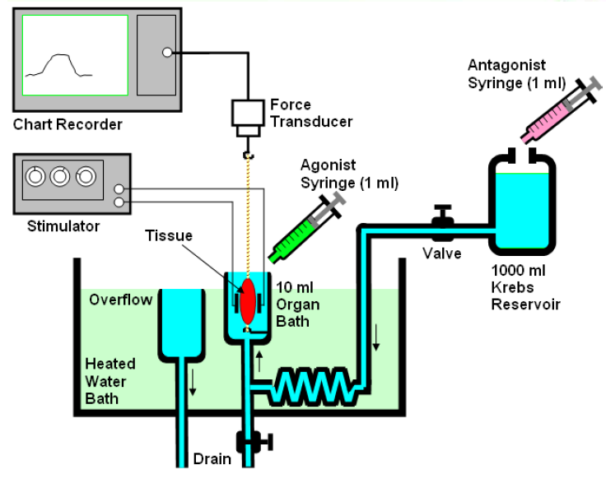
This experiment looks at concentration and response and the different mechanisms of antagonists.
Guinea pig ileum is smooth muscle with parasympathetic cells and postganglionic parasympathetic nerves. Receptors for ACh [muscarinic] and histamine [H1] are on the smooth muscle fibres with nicotinic receptors on ganglionic cells.
An antagonist has an affinity to a receptor but has no intrinsic activity. A competitive antagonist causes parallel displacement of a concentration-response curve to the right without a change in maximal response.

The experiment was set up as show. Carbogen aerates the tissue and the temperature is 32°C. Organ bath was washed out.
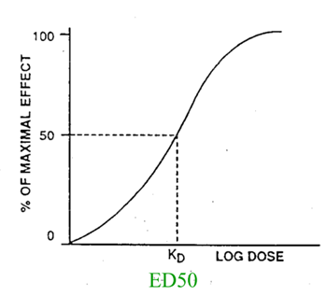
Stock Concentration x volume to be added to bath =Final bath concentration x volume of bath. For example, in order to expose the tissue to a concentration of 10⁻⁷ M it is necessary to add 0.1ml of a 10⁻⁵ M solution.

Results: Agonists – Carbachol and Histamine
Beginning with a low concentration of carbachol (10⁻¹⁰ M), increasing concentrations were added to the organ bath until maximal response was reached. When the tissue response on the chart recording reached a steady state for each of the concentrations, the agonist was washed out of the bath. This same method was repeated for histamine. Higher concentrations registered higher responses (measured in μv).

Antagonists – Atropine and Mepyramine
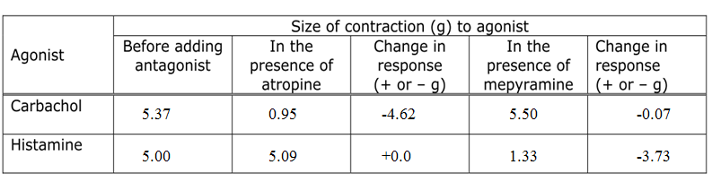
First the response to the EC₅₀ dose of an agonist in the presence of an antagonist was observed for each pair of agonist and antagonist. This was done to observe the reduction in response. It won’t tell us what sort of antagonist it is, it just shows with antagonises which agonist.

As seen by the above results, Carbachol had a greater reduction in response to Atropine while Histamine had a reduction in response to Mepyramine.
Thus increasing concentrations of carbachol was added to the bath in the presence of atropine until maximal response was reached. This was repeated for histamine with mepyramine.
Concentration response curves were then graphed as before.
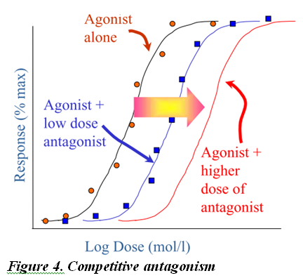
Carbachol and atropine.
The antagonist was found to be competitive as there was a parallel shift to the right in the response curve without a decrease in response, as shown by figure 4. So the gradient and maximal response are the same but the EC₅₀ is higher.
Histamine and mepyramine
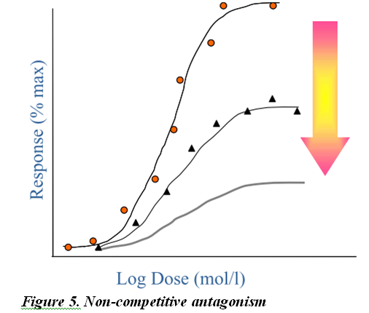

Pharmacology of the Human Autonomic Nervous System
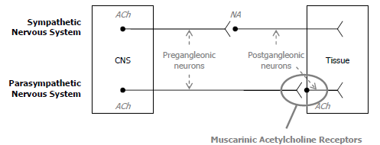
This experiment involved recording 3 control responses at 5 minute intervals following by a subcutaneous injection of 1.2mg of atropine. Observations were made at regular intervals.

Atropine is an anticholinergic/antimuscarinic drug that exhibits reversible competitive antagonism of muscarinic cholinergic receptors. This increases the sympathetic response. It has a half-life of 2 hours.

 | Method | Result / Effect
Pulse rate | Radial pulse | Initially pulse drops, as atropine has a partial agonist effect at the beginning, causing brachycardia. Pulse rises steadily after 5 mins as the dominant effect is antagonistic causing tachycardia.
Blood Pressure | Sphygmomanometer | Blood pressure varied over time. Atropine has no effect on blood pressure due to the little parasympathetic innervations of the blood vessels.
Pupil Size | Ruler | Pupil size increased with time. The constrictor muscle of the iris is under parasympathetic control, while the radial muscles causing the dilation of the iris are controlled by the sympathetic nervous system. Since atropine blocks the muscarinic acetylcholine receptors of the constrictor muscles, the radial muscles dominate, therefore the pupils will dilate.
Near Point | Move typed paper closer till subject cannot focus and measure distance | The near point increased as time progressed.  The ciliary muscle, which controls the shape of the lens within the eye, is under parasympathetic control. Atropine then blocks the ciliary muscle’s ability to contract and focus on short range objects, resulting in a larger near point.
Salivary Excretion | Swallow saliva, add 4 drops of citric acid, hold 30 seconds, Add 4 ml of water, swill for 15 seconds, spit into measuring cylinder. Volume – 4ml = saliva produced | There is a major decrease in salivary secretions. Atropine not only blocks the secretion of the salivary glands, but many other secretory glands, such as those in the gastrointestinal tract (pancreas).

Gene Therapy
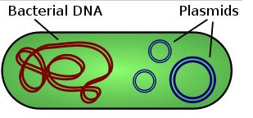
In this practical, we distinguish between a plasmid vector with no insert, a plasmid with a mutant gene, and plasmid with the correct gene. We do this with the aid of agarose gel electrophoresis.
Gene therapy is the use of genetic material to treat disease. The section of mutant DNA which causes the disease is identified. The correct/functional copy of that gene is inserted into a plasmid which is an extra chromosomal DNA molecule separate from the chromosomal DNA, capable of replicating independently from the chromosomal DNA.

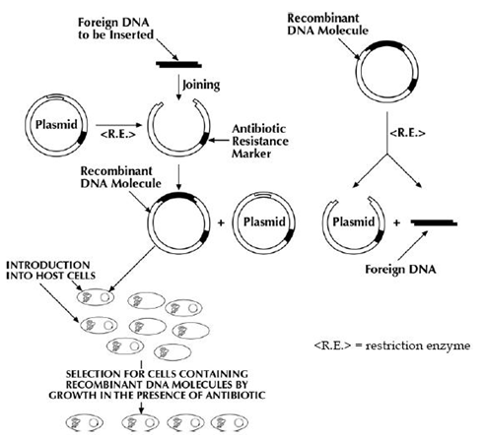
A recombinant DNA molecule is produced and this is inserted back into the bacteria such as E. Coli. As the bacteria replicated, the recombinant DNA molecule is replicated. The products are checked for the correct gene sequence and inserted into the patient. The recombinant process is random.

In our experiment, the mutant gene has a single (point) mutation at a restriction enzyme site. Restriction enzymes are enzymes that cut at sequence‐specific palindromic sites within DNA. Our restriction enzyme Mse I cuts at TTAA which is located on the mutated gene, thus it will not cut the normal gene.

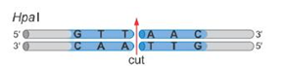
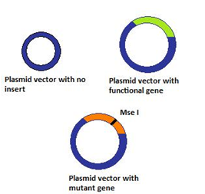
Part 1: Plasmid isolation protocol (not done due to time constraints)
This wasn’t done during class due to time constraints, however briefly, this is necessary to separate the multiple plasmids from the single bacterial DNA. NaOH (alkali) is added to denature the DNA, reducing them to single strands. Then potassium acetate (acid) is added to neutralise it. Due to their small size, the single-stranded DNA of plasmids are able to recombine to form double stranded DNA. The large, single bacterial DNA is unable to do so in the same amount of time. The centrifuge causes the bacterial DNA to precipitate, while the plasmids remain in the solution.
Part 2: Identifying different plasmids
There were 3 different types of plasmids:
A: plasmid with no insertion
B: plasmid with normal gene inserted
C: plasmid with mutant gene inserted.
All were incubated with the restriction enzyme Mse I and only one type of plasmid will have been cut into 2. Electrophoresis separated the DNA fragments, as its negative terminal repels DNA (all DNA is negatively charged). Electrophoresis involves placing agarose gel into an electrophoresis tank and applying voltage. Molecules are separated by particle size. The smaller the fragment, the faster it will travel and thus the further distance it will travel in a specific time interval.
A will produce one band as Mse I does not cleave it into 2. B will also produce one band as it doesn’t have the restriction enzyme site TTAA that they mutated gene has. However, A is smaller than B without any insertion of extra genetic material, and will thus travel a further distance. C will produce 2 bands as it is cleaved by Mse II.
Questions
1. How does the plasmid isolation protocol separate the plasmid DNA from the bacterial DNA?
Explained in a paragraph somewhere above
2. Which plasmid has the mutant copy of the gene? What are the other two plasmids?
The one with two bands. The plasmid without an insert is the single band that travels further than the other single band which is the plasmid with the correct gene.
3. Can you determine which plasmid has the correct gene just by looking at the isolated plasmid?
No, there’s no difference in size between the good and mutant gene because the mutation is just a point mutation.
4. What do you need to do to confirm that the normal copy of the gene is ok?
We need to sequence the gene to confirm that the base pairs are correct.
5. Why does the single base change that is in this gene cause the disease?
The change to a TTAA is actually a stop codon. The rest of the DNA is not expressed and the protein is not produced.
4. Based on the information given on the next page, how is DNA used in gene therapy protocols?

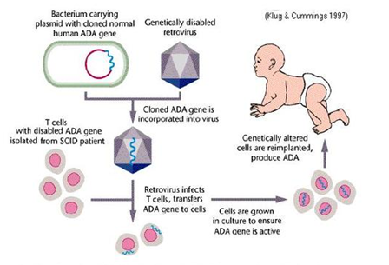
While most gene therapy protocols are being developed to target cancer, the other obvious targets for GT are monogeny disorders where a single defect in a single gene is responsible for the development of the disease (e.g. cystic fibrosis?). The DNA sequence that produces the functional protein which is absent or altered in the patient is cloned and may be inserted into a genetically disabled retrovirus. This can occur in vivo or in cells harvested from the patient and cultures in the laboratory. They are cultured for replication, checked, and administered to the patient.
Note: Plasmids can’t replicate in humans, so we must insert them into the cytoplasm of cells and put them back into humans. This means that when the cell replicates, it has a 50% chance of getting the implanted recombinant gene, and 50% of getting the mutant gene. Retroviruses can be inserted directly into the chromosomes in the nucleus, meaning that when mitosis occurs, all daughter cells will have the good gene. However, retroviruses affect oncogenes (a cancer-causing gene) and activate it, and may cause cancer. Therefore plasmids are safer.
SCID = severe combined immunodeficiency disease results from multiple different defects. The most common form of SCID is X-linked SCID (resulting from mutation in IL-2 gamma receptor chain) which is fatal unless treated by bone marrow transplantation. Affected males have profoundly diminished numbers of peripheral blood T cells and not functional B cells.

Effect of Beta-Adrenoceptor Agonists on Exercise Induced Cardiovascular Changes

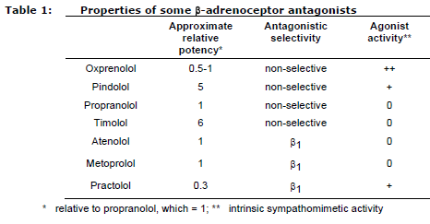
β-adrenoceptor antagonists are commonly prescribed to treat elevated blood pressure.
Atenolol is a selective β1-adrenoceptor antagonist and has no intrinsic sympathomimetic activity. In contrast, pindolol is a non-selective β-adrenoreceptor antagonist which has intrinsic sympathomimetic activity (Table 1). Their effects on cardiac function will be studied under two conditions: at rest, and during a period of exercise. A therapeutically effective dose of each drug will be used and the trial will be conducted "double blind" with a placebo (vitamin B6) control. The identity of the drug/placebo will be revealed at the end of the class.

Receptor | Location | Major function
α1 | Most sympathetic target tissues, including blood vessels, skin | Vasoconstriction of resistance vessel (arterioles) and capacitance vessels (veins)
α2 | Presynaptic Nerves | Decrease neurotransmitters release
β1 | Heart | Increase in heart rate and force of contraction
β2 | Blood vessels  Bronchioles,  Bladder and intestine SM | Vasodilation  Bronchodilation  Smooth muscle relaxation
β3 | Fat tissue | Lipolysis

  - Atenolol:
    - Selective β₁-Adrenoreceptor Antagonist
    - No Intrinsic Sympathomimetic Activity:
      - Definition – Intrinsic Sympathomimetic Activity: can show both agonism and antagonism at a given receptor
        - Partial Agonist: can bind and activate a given receptor, but have only partial efficacy at the receptor relative to a full agonist
        - Competitive Antagonist: when also in presence of full agonist (e.g. endogenous catecholamines like noradrenaline in this case) since competition for receptor binding produces net decrease in receptor activation compared to a full agonist alone.
  - Pindolol:
    - Non-Selective β-Adrenoreceptor Antagonist
    - Partial β-Agonist Activity
    - Intrinsic Sympathomimetic Activity

Results: Resting HR & BP; Measurement before and after exercise; Fatigue rating after exercise
How else might you plot and analyse the results? What advantages would be gained by plotting the data in a different way?
    - Split the Results by Gender:
      - More Consistent Results (Since females had a smaller decrease in heart rate than males)
    - Exclude Extremely Fit and Unfit People:
      - Reduce Random Variation
    - Use all 3 Treatments on Same Person:
      - Reduce Variance
      - Increase Power of the Study
    - Use More Subjects
      - More Credible Results
    - Repeated Experiment Multiple Times
      - Reliability
What effect would you expect β-adrenoceptor blockade to have on:
    - resting & exercise heart rates?
  - No effect since sympathetic nervous system is not active at rest

    - resting blood pressure (systolic & diastolic)?
  - Decreased Heart Rate (Since they block β₁ activity which increases heart rate)
    - lung function?
β₂ receptors in the smooth lung are involved in relaxation in the bronchi. Thus β blockers result in reduced opening of the bronchi, reducing ventilation. They can also result in bronchospasm.
  - Only Slight Decrease in Systolic and Diastolic Pressures because:
    - Most of Effect Takes Weeks to Develop Through Action of Renin-Angiotensin-Aldosterone System (Kidneys)
    - Subjects were Normotensive
    - Small Decrease in BP Probably Due to Reduced Cardiac Output (Block β₁ activity, Reducing Heart Rate and Stroke Volume)

    - Peak Expiratory Flow?
  - No Significant Effect Because:
    - Atenolol: only acts β₁ activity (i.e. no effect on β₂ receptors in airways)
    - Pindolol: does act on β₂ activity in airways (blocking β₂ causes brochoconstriction, reducing peak expiratory flow rate) but effect only significant in asthmatics (not in healthy people)

    - Fatigue?
  - Increased because:
    - β-Blockers Decrease Cardiac Output: reducing blood supply to muscles
    - People Got Tired

Did you observe these predicated effects? If not can you explain why?
  - Resting Heart Rate:
    - Observed Slight Decrease in Resting Heart Rate Because Our Subjects Had Just Exercised and Not Fully Recovered
  - Exercise Heart Rate:
    - Yes
      - Placebo: Initial Increase in HR After Exercise then Plateaued
      - Atenolol: Initial Increase in HR After Exercise Then Decreased (Statistically significant at 120 mins)
      - Pindolol: Initial Increase in HR After Exercise Then Decreased (Statistically significant at 60 minutes reflecting more rapid onset of action)
  - Resting Blood Pressure (Systolic and Diastolic):
    - Yes, There was only very small decrease (5-10mm Hg) in systolic BP but it was not statistically significant (probably needed more subjects).
  - Peak Expiratory Flow Rate:
    - Yes, though there was a slight increase in peak expiratory flow rate due to:
      - Exercise Induced Brochodilation
      - Subjects got Better at Using Machine (i.e. Training Effect)
      - Note - Huge Variation in measurement due to factors such as Gender
  - Fatigue:
    - Yes.
      - Atenolol: was not statistically significant but may have been with more time
      - Pindolol: was statistically significant in last 2 time period (reflecting faster onset of action)

Did the subjects in your group who took a β-adrenoceptor antagonist, report any other physiological effects?
  - Possible Side Effects from Single Dose Include:
    - Fatigue
    - Dizziness
    - Reduction in Trembling
    - Laboured Breathing
    - Headaches
    - *Nightmares (Due to CNS effects though this is significantly lower in newer versions)
Extra Note – The consent sheet says a single dose may be associated with tremors but that contradicts every other source I’ve seen

What differences in the pharmacological properties of atenolol & pindolol may influence their efficacy?
  - Described Above
What might be the advantages of a β-adrenoceptor antagonist with intrinsic sympathomimetic activity?
  - May be Useful in Patients with Excessive Bradycardia Due to Sustained β-Blocker Activity due to:
    - Low Level Agonistic Activity on β₁ Receptor, Increasing HR at Rest (when sympathetic nervous system is not active and therefore no endogenous ligand is present)
    - Antagonistic Activity Compared to Full Agonist (Endogenous Ligand), Reducing HR in Exercise

What might be the advantages of a β-adrenoceptor antagonist with β1-adrenoceptor selectivity?
  - Fewer Side Effects from β₂ Activation Since β₁ is Cardioselective
    - Brochospastic Reactions: β₂ keeps bronchial system open ensuring adequate oxygen is provided to the body. Blocking β₂ is particularly dangerous in asthmatics.

In what respects did the class results display differences in the profile of activity between atenolol and pindolol?
  - Many differences e.g. speed of onset, selective activity vs non-selective activity, sympathomimetic activity etc etc

How do these differences relate to the properties of atenolol and pindolol (Table 1)?
  - Basically what’s written in the tables

Drug Metabolism
This experiment shows how the pH affects urinary excretion of different drugs depending on their acidic or basic nature. In this prac we use salicylic acid (in aspirin) which is weakly acidic.
The salicylic acid is administered in the form of aspirin (acetylsalicylic acid) and urine pH is made either more acidic or more basic by the ingestion of either ammonium chloride (weak acid) or sodium bicarbonate (weak base), respectively.
The diffusion of a drug across a cell membrane depends on how readily it can go from its water soluble state to its lipid soluble state. This in turn depends on whether the drug is charged, with charged substances being more polar and hence less able to diffuse through the lipid bi-layer.
Salicylic acid, like any weak acid, can exist in a charged/ionised form and an uncharged/unionised form according to the equation:
H+ + Ionised Drug (A-) ↔ Unionised Drug (A)
Hence the concentration of H+ (pH) will affect the concentration of unionised drug that can diffuse across a cell membrane

Method:
1) Using known concentrations of salicylic acid in solution and measuring their absorbance, you plot a standard curve of absorbance.
2) You give: - one person aspirin
- one person aspirin + sodium bicarbonate (base)
- one person aspirin + ammonium chloride (acid)
- one person just water (control)
3) Get them to pee immediately after taking their dose to obtain a control sample.
4) Get them to pee again after like 60-80 min to obtain test sample.
5) Use pH strip to test pH of both samples and get absorbance for test sample.
6) Compare absorbance with standard curve to work out salicylic acid concentration.
Results:
- person with aspirin has middle/normal salicylic acid clearance
- person with aspirin + base (sodium bicarb) has high clearance
- person with aspirin + acid (ammonium chloride) has low clearance
- person with no aspirin should have 0 clearance.

Questions:
1) What effect does urine pH have on salicylate clearance?
High urine pH (basic) causes more clearance because more aspirin is ionised in nephrons and cannot pass back through membrane into blood.
Low urine pH (acidic) causes less clearance because less aspirin ionised and therefore can more easily pass back through membrane into blood.
2) What are the advantages and disadvantages of increasing rate of clearance?
Advantages: - retained in body for less time = less long term adverse effects
- less likely to overdose or cause toxicity
Disadvantages: - lower dose retained in body therefore may not reach therapeutic effect
- may need to repeatedly administer to maintain therapeutic effect
3) 35 y.o women diagnosed with acute salicylate intoxication. Stomach doesn’t have drug since time of ingestion >2hrs. What could be done to increase excretion?
Alkalise urine to increase excretion eg: by giving sodium bicarb by infusion (because acute therefore needs immediate IV)
1) List some weak acids.
Penicillin, fenoprofren, ibuprofen, naproxyn, phenoburbital.
2) What factors can alter urine pH? Describe how you would modulate dose of a drop if it was a weak acid.
High protein diet = more acidic
Diabetic à ketoacidosis = more acidic
Prolonged exercise à lactic acid = more acidic
UTIs, obstruction and renal tubular disease = more alkaline
Metabolic alkalosis = more alkaline
Drugs eg: acetazolamides (diuretic) = more alkaline
More vegies = more alkaline
Basically for stuff that makes urine more acidic give lower dose or less frequent because less cleared.
For stuff that makes more basic give dose more frequent because more cleared.

