Endocrine system tutorial exercise

Aims:
The aim of this exercise is for students to revise and expand their understanding of the:
- location of the various endocrine organs;
- hormones secreted by these endocrine glands;
- major actions of the hormones;
- control of hormone levels;
- symptoms of hypo- and hyper-secretion of some of the hormones.

Key concepts:
Hypothalamic releasing factors, pituitary hormones, target glands, hormonal control, actions of hormones, hyper- and hypo-secretion of hormones

Process:

Students should complete the exercises in this tutorial prior to attending the session. The exercises will require consultation of the textbook (Berne & Levy Principles of Physiology, see below) as well as the physiology lecture notes from the lectures on ‘Hormones of the hypothalamic-pituitary axis’ and ‘Structure and Function of the Thyroid’. The tutors will work through the exercises with the tutorial group.

References for self-directed learning:

Prescribed textbook:

Genuth, S.M. (2007). General principles of endocrine physiology (Chapter 41). In Levy, M.N., Koeppen, B.M & Stanton, B.A. (Eds.) Berne & Levy Principles of Physiology (4th ed., pp. 589-600). Philadelphia, PA: Mosby.

Genuth, S.M. (2007). Hypothalamus and pituitary gland (Chapter 45). In Levy, M.N., Koeppen, B.M & Stanton, B.A. (Eds.) Berne & Levy Principles of Physiology (4th ed., pp.647-662). Philadelphia, PA: Mosby.

Genuth, S.M. (2007). Thryoid gland (Chapter 46). In Levy, M.N., Koeppen, B.M & Stanton, B.A. (Eds.) Berne & Levy Principles of Physiology (4th ed., pp.663-675). Philadelphia, PA: Mosby.

Genuth, S.M. (2007). Adrenal cortex (Chapter 47). In Levy, M.N., Koeppen, B.M & Stanton, B.A. (Eds.) Berne & Levy Principles of Physiology (4th ed., pp.676-690). Philadelphia, PA: Mosby.

Additional reading:

Gardner, D.G. and Shoback, D. (2007). Greenspan's Basic & Clinical Endocrinology, 8th Ed. Lange Educational Library. [available as an electronic text book via the UNSW library; search for the title in the library resource database].

Question 1
Primary Endocrine Organs
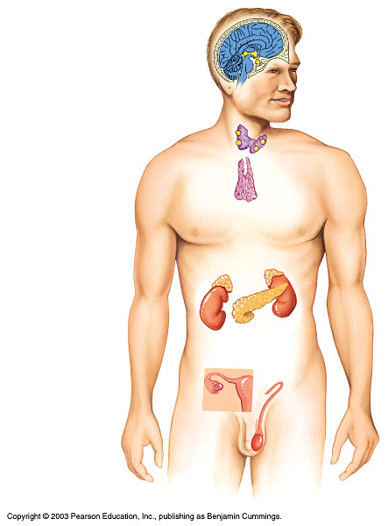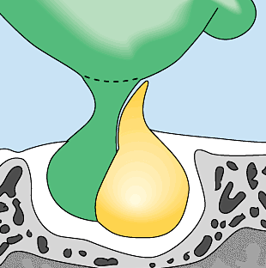The following diagram schematically represents various endocrine organs present in the body. Write the name of the endocrine-producing organ next to the letter in the table below and then complete the table.
B
C
D
A
E
F
G
H
I
J
K
L
- Endocrine organ present in pregnant women _______________

A. Pineal gland | G. Thymus
B. Hypothalamus | H. Adrenal gland
C. Anterior pituitary gland | I. Pancreas
D. Posterior pituitary gland | J. Ovary
E. Thyroid gland | K. Testes
F. Parathyroid glands | L. Placenta

With regard to the diagram above, fill in the table below.

GLAND | HORMONE/S SECRETED | MAJOR ACTION/S
A pineal | melatonin | Sets circadian rhythm (light/dark cycle)
B hypothalamus | Pituitary gland releasing and inhibiting hormones (e.g. somatostatin, GHRH, TRH, CRH, GnRH, dopamine)  ADH synthesised  Oxytocin synthesised | Control the production and release of anterior pituitary hormones  See under posterior pituitary
C anterior  pituitary | See question 2
D posterior  pituitary | ADH stored and secreted  Oxytocin stored and secreted | -Increases permeability of nephron to water  -Uterine muscle contraction especially at childbirth; breast tissue contraction – expulsion of milk.
E thyroid | T₃ , tri-iodothyronine  T₄ , thyroxine  calcitonin | - Regulate metabolism, maintain body temperature  - Decreases plasma Ca mainly by inhibiting bone resorption. (Mnemonic: “calcitonin tones down calcium”.)
F parathyroid | Parathyroid Hormone | ↑plasma Ca by promoting renal reabsorption of Ca, causing resorption of bone and ↑Ca absorption in GIT
G thymus | Thymosin | Regulates T cell function
H adrenals | Cortex- mineralocorticoids  (e.g. aldosterone)  - glucocorticoids  (e.g. cortisol)  - androgens  (e.g. dehydroepiandrosterone, DHEA)  Medulla – catecholamines(adrenaline  and noradrenaline) | - ↑ Na reabsorption by kidneys  - respond to stress, promote gluconeogenesis, reduce inflammation  - influence sexual development & libido  ↑ HR & cardiac contractility, affects smooth muscle contractility, ↑ glycogen breakdown→↑ blood glucose
I pancreas | Glucagon  Insulin  Somatostatin | - Increases blood glucose and mobilises stored energy  - Decreases blood glucose and promotes energy storage (and growth in fetus, child),  ↑synthesis and ↓ breakdown of glycogen,↑protein synthesis,  ↑triglyceride storage,  ↓mobilisation of fat stores  -inhibits insulin release; retards digestion and absorption in GIT
J ovaries | Estrogen & progesterone & Inhibins | Promote development of primary & secondary sex characteristics in females, development of uterus before & during pregnancy.
K testes | Testosterone & Inhibins | Promotes development of primary & secondary sex characteristics in males, sperm development
L placenta | Estrogen, progesterone, human chorionic gonadotrophin, human placental lactogen, plus many others | Growth and maintenance of placenta and fetus; maternal adaptation to pregnancy

Question 2
Hypothalamic-Pituitary Axis
- The diagram depicts the relationships between the hypothalamus, the pituitary and the target glands. Identify the releasing factors from the hypothalamus. Indicate the hormones that are released from the anterior pituitary in response to the hypothalamic releasing factors. Finally indicate the target organs of the anterior pituitary hormones and any hormones that may be released from these target glands. (Students have an unlabelled version)

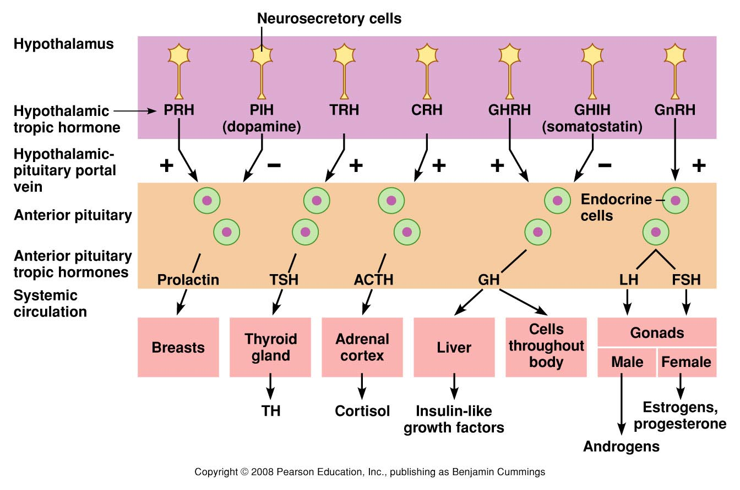
Note: All are stimulatory hormones except for prolactin inhibiting hormone (which is dopamine) that inhibits the release of prolactin and growth hormone inhibiting hormone (also called somatostatin) that inhibits the release of growth hormone.

- Describe the mechanism by which the thyroid hormones are able to regulate the secretion of thyrotropin releasing hormone and thyroid stimulating hormone. What other hormones also regulate hypothalamic and anterior pituitary hormones in the same fashion?
Thyroid hormones have a negative feedback loop acting on the hypothalamus to inhibit the secretion of thyrotropin releasing hormone (TRH), and on the anterior pituitary to inhibit the secretion of thyroid stimulating hormone (TSH). Similar negative feedback loops are also seen for the sex steroids produced in the gonads. So testosterone in males has negative feedback loops to inhibit gonadotropin releasing hormone (GnRH: hypothalamus) and LH and FSH (anterior pituitary). Similarly, estrogen and progresterone have negative feedback loops to inhibit GnRH (hypothalamus) and LH and FSH (anterior pituitary). Just prior to ovulation (2-5 days prior) estrogen levels above 200 pg/ml have positive feedback upon the hypothalamus and anterior pituitary, stimulating the secretion of GnRH and LH and FSH. Insulin-like growth factors have negative feedback, inhibiting secretion of growth hormone releasing hormone (GHRH; hypothalamus) and growth hormone (GH; anterior pituitary). Cortisol from the adrenal gland has negative feedback, inhibiting corticotrophin releasing hormone (CRH; hypothalamus) and adrenocorticotropic hormone (ACTH; anterior pituitary).

Question 3
Altered secretion of hormones
Describe some of the clinical symptoms that might be seen as a result of:
- hyper and hyposecretion of Thyroid Stimulating Hormone (TSH) in an adult;
- hyposecretion of Follicle Stimulating Hormone (FSH) and Luteinizing Hormone (LH) in an adult;
- hypersecretion of growth hormone in an adult;

TSH: Stimulates the thyroid gland to produce thyroid hormones and these have many actions throughout the body. Symptoms in adults may include:

Hyposecretion:
- decreased basal metabolic rate, weight gain;
- coarse and thinning hair;
- dry skin;
- slow body movements;
- inability to tolerate cold temperatures;
- feeling tired, sluggish, or weak;
- memory problems, depression, difficulty concentrating;
- brittle nails, or a yellowish tint to the skin;
- constipation;
- heavy or irregular menstrual periods that may last longer than 5 to 7 days;
- goitre (visibly enlarged thyroid) may be present – e.g. endemic goitre – in areas where iodine is insufficient in the soil, this lack prevents production of T3 and T4. As a result, no hormone is available to inhibit production of TSH by the anterior pituitary, causing excessively large quantities of TSH. The TSH then stimulates the thyroid cells causing thyroid gland growth.

Hypersecretion:
- increased basal metabolic rate;
- weight loss;
- increased appetite;
- nervousness, restlessness;
- tachycardia (increased heart rate), palpitations;
- heat intolerance;
- increased sweating;
- fatigue;
- frequent bowel movements;
- menstrual irregularities in women;
- goitre may be present. Hyperthyroidism has a number of causes. If there is a hypersecretion of TSH, then this is likely due to a pituitary tumor.

FSH and LH: These gonadotrophins stimulate the ovaries and testes to produce the sex steroid hormones such as estrogens, progesterone and androgens. A lack of FSH and LH will mean that the synthesis and secretion of these sex steroids will be significantly reduced and it is the lack of these hormones that produce most of the sign and symptoms observed. Consequently, in women, lack of the gonadotrophins cause problems with the menstrual cycle, fertility and libido. In men, there may be problems with fertility, impotence and libido.

In women:
- decreased production of estrogen and progesterone;
- altered menstrual function, ranging from regular anovulatory periods to amenorrhea;
- hot flushes;
- decreased libido;
- breast atrophy;
- vaginal dryness;
- urinary tract infections;
- incontinence;
- osteoporosis.

In men:
- decreased testosterone production;
- decreased fertility;
- decreased libido;
- varying degrees of erectile dysfunction;
- decreased hair growth;
- muscle weakness;
- fatigue.

GH: Overproduction of growth hormone in adults is usually due to a pituitary tumor. It can lead to a condition called acromegaly. Symptoms include headaches and visual problems (because of the pressure from the large tissue mass of the pituitary tumour pressing upon the optic chiasma), sweating, soft tissue swelling, enlarged hands and feet, as well as some changes in facial features, such as increased prominence of the jaw. In children, where the epiphysial plates have not yet closed, overproduction of GH will cause excessive growth of the long bones, resulting in gigantism.

Question 4
Adrenal gland hormones
- Complete the following table by naming the three zones of the adrenal cortex and the primary hormone(s) that are secreted by each zone.
Adrenal Cortex | Hormone(s) secreted
Zona glomerulosa | Mineralocorticoids, e.g. aldosterone
Zona fasiculata | Glucocorticoids (e.g. cortisol, corticosterone) and androgens (e.g.dehydroepiandrosterone, androstenedione)
Zona reticularis | Glucocorticoids (e.g. cortisol, corticosterone) and androgens (e.g.dehydroepiandrosterone, androstenedione)
- List the major actions of the following classes of adrenal cortex hormones.
Mineralocorticoids: acts on kidneys, colon, sweat and salivary glands to maintain normal extracellular concentrations of Na⁺ and K⁺ and as a consequence extracellular volume.
Glucocorticoids: secreted in response to physical or emotional stressors to have metabolic effects that increase the availability of metabolic substrates (e.g. glucose and lipids) so that the body can respond to the stressors.

Question 5
Regulation of blood glucose
The following diagrams represent the feedback loops for regulation of insulin and glucagon secretion from the pancreas. Complete the diagrams by filling in the blanks that represent the stimulus for secretion and the actions of the hormones to maintain homeostasis.
Metabolic actions
Adipocytes:
⇑ Glucose uptake
⇑ Tryglycergide synthesis
Liver:
⇑ Glucose uptake
⇑Tryglyceride synthesis
Liver and muscle:
⇑ Glucose uptake
⇑Glycogen synthesis
Most cells:
⇑ Glucose uptake
⇑ a.a. uptake
⇑ Protein synthesis
Consequences to Plasma levels of:
Glucose ⇓
Amino acids ⇓
Free fatty acids ⇓
Metabolic actions
Adipocytes:
⇑ Lipolysis
Liver:
⇑ Glycogenolysis
⇑Gluconeogenesis
⇑ Ketogenesis
Consequences to Plasma levels of:
Glucose ⇑
Free fatty acids ⇑
GUCOSE HOMEOSTASIS
Hormone:
Glucagon
PANCREAS
α cells
β cells
Hormone:
Insulin
Increased metabolic demand
Plasma levels of:
Glucose ⇓
Amino acids ⇑
Free fatty acids ⇓
Ingesting a meal
Plasma levels of:
Glucose ⇑
Amino acids ⇑
Free fatty acids ⇑
+
+
Beta cells of the pancreas are stimulated to release insulin with increased plasma levels of glucose, amino acids and free fatty acids, for example (and most commonly) follow a meal. Insulin then has actions on most tissues in the body to increase glucose uptake and amino acid (a.a.) uptake from the circulation. Insulin also stimulates protein synthesis in most tissues. In addition, insulin stimulates triglyceride synthesis in adipocytes and the liver, and glycogen synthesis in the liver and muscle. So there is both uptake of these substrates for use within cells and storage of these substrates in the liver and adipocytes. As a consequence, plasma levels of glucose, amino acids and free fatty acids all decrease, removing the stimulus on beta cell secretion.
Alpha cells of the pancreas are stimulated to release glucagon with increased plasma levels of amino acids and decreased levels of glucose, and a sharp decrease in free fatty acids. Not shown is that high levels of glucose also suppresses glucagon secretion and insulin has a paracrine action to suppress glucagon secretion. Glucagon stimulates lipolysis in adipose tissue and in the liver it stimulates glycogenolysis, gluconeogenesis and ketogenesis. As a result there is an increased availability of these substrates (glucose and free fatty acids) in the plasma, thus removing the stimulus on alpha cell secretion.
Students often confuse ‘glucagon’ with the glucose polymer ‘glycogen’.

