Renal Regulation of Acids and Bases
pH
Normal arterial pH is 7.40 (7.35-7.43) and venous pH is slightly lower.
These body fluids are slightly on the alkaline side of neutrality (7.0)
pH is tightly regulated in the body. Normal pH is important for normal metabolic function e.g. enzyme activity, blood clotting and muscle contraction all depend on optimum pH.
Revision Slides
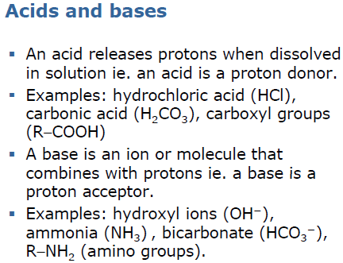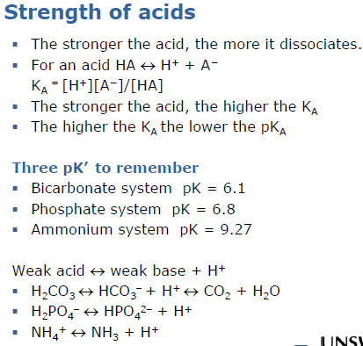
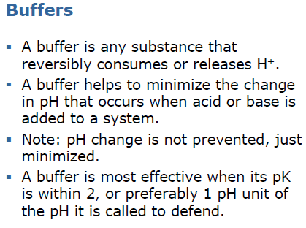
Body Acid-base Balance
The metabolism produces acids which threatens to disturb body pH.
Cellular metabolism of CHOs and fats produces about 15-20mol/day of CO2 (which when dissolved in water forms a weak acid – volatile acid). [Assuming adequate insulin and tissue perfusion; otherwise non-volatile acids β-hydroxybutytric acid and lactic acid are produced).]
As well small amounts of non-volatile or fixed acids are produced:
- Sulfuric acid – from the metabolism of methionine and cysteine
- Hydrochloric acid – from the metabolism of lysine, arginine and histidine
- Phosphoric acid – phospholipids, and nucleic acids.
Overall 50-100mEq/day (70mEq/day; 1mE1/kg/day) however this concentration varies with diet and is decreased generally for vegetarians.
There are however 3 processes that allow the balance of body-acid:
- Buffering
- Respiratory regulation of pH
- Renal (kidney) regulation of pH
Renal Regulation of pH
The kidney generates new bicarbonate to replenish the bicarbonate lost in buffering.
Simultaneously, it excretes acids equivalent to the amount of fixed acid produced each day. This is excreted as titratable acid and ammonium.
Quantitatively, it is very important that most of the filtered bicarbonate is reabsorbed. Filtered bicarbonate = 24mmol/L * 180L/day = 4320mEq/day.
If body pH is too high, the kidneys can secrete bicarbonate.
Net acid excretion
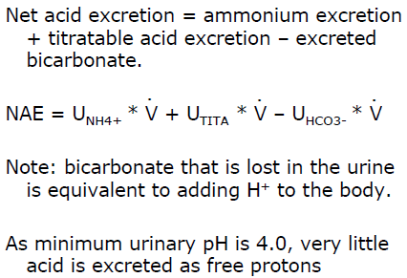
Bicarbonate reabsorption
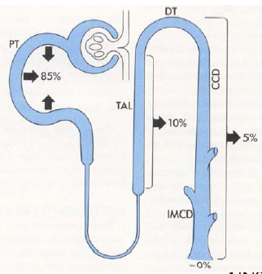
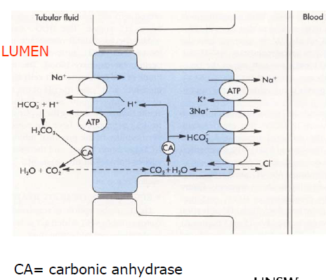
Factors influencing bicarbonate reabsorption

Excretion of protons with “non-bicarbonate buffers”
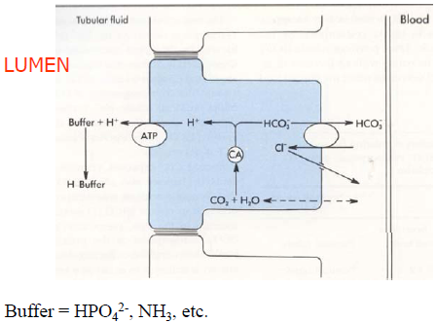
Titratable Acid
The amount of strong base required to titrate the pH of urine back to the pH of glomerular filtrate (ie. pH of plasma).
The excretion of titratable acid depend mainly on phosphate.
Others include: β hydroxybutyrate and acetoacetate in diabetic ketoacidosis AND creatinine
If urinary pH > 7.4 then there is no titratable acid.
Phosphate as an urinary bladder
Phosphate is derived solely from the diet
The amount excreted as titratable acid depend on filtered load – amount reaborobed
About 75% reabsorbed means 36mmol/day is available for titration
Acidosis causes an adaptive inhibition of phosphate reaborption, but the amount is modest.
Mainly phosphate reabsorption is regulated to maintain phosphate balance.
Ammonia is the most important urinary buffer.
Ammonia is produced by the kidneys. Its synthesis can be varied in response to acid-base requirements.
Ammonium is produced in the proximal tubular cells from glutamine.
Glutamine enters the cells by Na+ coupled co-transport from both luminal and peritubular fluid.
2NH₄⁺ is produced from each glutamine.
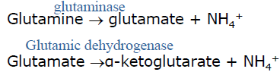
Enzymes are up-regulated in acidosis:
- Takes several days
- Opposite in alkalosis
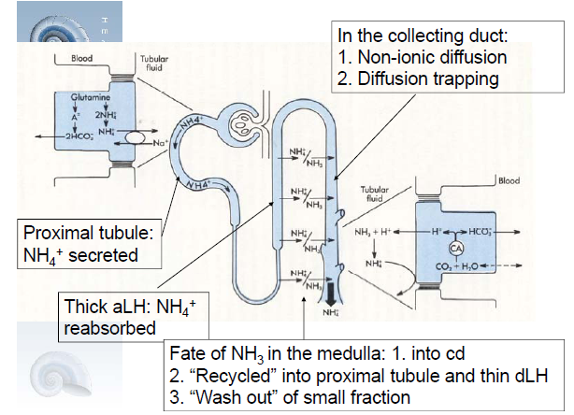
Renal venous levels of ammonia are higher than renal arterial levels.
Important that NH₄⁺ is excreted. If it returns to the blood, it negates the effect of the new bicarbonate generation.
The lower the urinary pH, the more NH₄⁺ is trapped.
At pH 7.2 the ration of ammonia/ammonium is approximately 1:100.
Ammonium does not contribute to titratable acid. As the pK is high, titration of urine to 7.4 does not cause the H+ to be release from ammoniu,.

Renal Adaptation to Acidosis
Secretion of H+ by the nephron is stimulated by:
- The entire filtered load of bicarbonate being reabsorbed.
- The net acid excretion is increased.
Thus the production and excretion of ammonium is stimulated.
New bicarbonate is generated which is returned to the plasma to increase the plasma [bicarbonate].
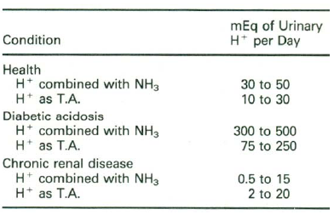
Renal Adaptation to Alkalosis
Secretion of H+ by the nephron is inhibited by:
- Bicarbonate reabsorption being reduced
- Net acid excretion is reduced.
Bicarbonate secretion by intercalated cells in cortical collecting duct is stimulated (Type B cells).

